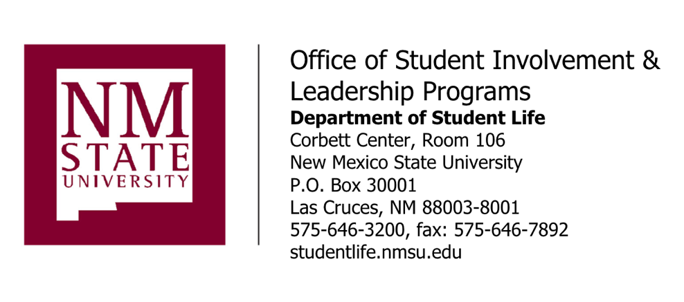

January 14, 2021

TO: Chartered Student Organization Leaders Student Organization Faculty/Staff Advisors
FROM: Sarah Edwards, Ph.D.
Director of Student Involvement and Leadership Programs
CC: Ann C. Goodman, Ph.D.
Associate Vice President & Dean of Students
RE: NMSU Chartered Student Organization Spring Semester Event Requirements

– Effective January 01, 2021

Due to the ongoing COVID-19 pandemic, the student organization experience will again look different this spring semester, with nearly all student organization activity continuing to shift to outdoors or online. Having seen examples and/or talking with students we are confident that our NMSU student organizations will continue to use this situation as a chance to think creatively and to be a central engagement feature of Aggie life at NMSU.

Planning programs for Spring? With our current COVID restrictions, here are some strategies and types of events we would encourage you to consider:
- Outdoor tabling/Grab and Go
- Since there is a 5-person gathering limit, tabling or other grab-and-go style options are ideal to allow individuals to still pick up materials or other physical handouts and interact face-to-face, but just in a constantly moving process.
- It will be important to still follow safe-handling practices for preparing all materials being distributed.
- If the handouts might produce a crowd, it will be important to have a plan in place to comply with the 5-person gathering limit, tabling or other grab-and-go style options are ideal to allow individuals to pick up materials or other physical handouts and interact face-to-face in a constantly moving process.

- Activities at the Outdoor Stage
- Limit to 2 people per square in the Corbett Outdoor Stage grid, skipping every other square, activities at the outdoor stage can accommodate approximately 50 people.
- Activities most likely to be approved under current guidelines are movie nights and trivia events.
- Anything that could be interpreted as a performance (dj event, singers, instructors, etc) will be assessed on a case by case basis.
- Performances connected to the Academic Mission will be given special reviews. It is strongly encouraged that organizations and departments looking to program for Spring seek out academic partnerships and consider how their activities can and do connect to the academic mission.

- Drive-Thru Events
- Handing out items via a drive-thru method is also viable so long as safe-handling practices are followed.
- It is also strongly encouraged to review and match the guidelines for Curbside Delivery

- Drive-In Events
- While Drive-In style events are allowed, the attendance cap is currently set at 5 people per vehicle, with a maximum of 10 vehicles.
- If planning this kind of event, it is strongly encouraged to review and follow the state guidelines for Drive-Ins.

Suggestions for all event planners:
- If the event can be successfully completed virtually, that is still the preferred and safest options.
- ALWAYS wear a mask and practice social distancing at any in person events and whenever on campus.

Alleged violations of these policies by a student or student organization should be reported to the Office of the Dean of Students, dos@nmsu.edu or 575-646-1722.

Potential consequences for failure to abide by these policies may include, but are not limited to warnings, loss of privileges, revocation of university charter and frozen financial accounts.

